|  |  |  |  |  |  |  |  |  |  |  |  |  |
| --- | --- | --- | --- | --- | --- | --- | --- | --- | --- | --- | --- | --- |
| REPUBLIC OF CAMEROON  Peace -Work-Fatherland  UNIVERSITY OF BUEA  P.O BOX 63  Buea, Southwest Cameroon  Tel: (237) 674354327  Fax: (237) 3332 22 72  UB logo  **FACULTY OF ENGINEERING AND TECHNOLOGY**  **DEPARTMENT OF COMPUTER ENGINEERING**  CEF440: INTERNET PROGRAMMING(J2EE) AND MOBILE PROGRAMMING PROJECT REPORT  PRESENTED BY:   |  |  | | --- | --- | | NAME | MATRICULE | | KENFACK SAMEZA VICTORIN-JOY | FE21A213 | | POKAM NGOUFFO TANEKOU | FE21A299 | | FOZAO JARID NZOLEFACK | FE20A042 | | MBUNGAI GEORGE BERINYUY | FE21A234 | | MBUA SEDRICK GOBINA | FE21A233 |   **COURSE COORDINATOR**  DR. NKEMENI VALERY |

Table of Contents

**CHAPTER ONE: GENERAL INTRODUCTION** 4

**1.** **Background and Context of the Study** 4

**2.** **Problem Statement** 4

**3.** **Objectives of the Study** 5

**3.1** **General Objective** 5

**3.2** **Specific Objectives** 5

**4.** **Proposed Methodology** 5

**5.** **Significance of the Study** 6

**6.** **Scope of the Study** 6

**7.** **Delimitation of the Study** 6

**8.** **Definition of Keywords and Terms** 7

**CHAPTER TWO: REQUIREMENT GATHERING** 8

**1.** **Requirements Gathering Activities** 8

**1.1** **Survey** 8

**1.2** **Interviews** 8

**1.3** **Studying Existing Documentation** 8

**1.4** **Brainstorming Sessions** 9

**1.5** **Overall Gathered Requirements** 9

**CHAPTER THREE: REQUIREMENT ANALYSIS** 11

**1.** **Objectives of Requirement Analysis** 11

**2.** **Requirements Categorization** 11

**2.1** **Functional Requirements:** 11

**2.2** **Non-Functional Requirements** 12

**2.3** **User Requirements** 13

**2.4** **System requirements** 14

**2.5** **Legal and Regulatory Requirements** 14

**3.** **Acceptance Test Planning** 15

**3.1** **How it was done** 15

**3.2** **The Test Plan** 15

**4.** **Conclusion** 15

**CHAPTER FOUR: SYSTEM MODELLING AND DESIGN** 16

**1.1.** **Context Diagram** 16

**1.2.** **Use case Diagram** 18

**1.2.1.** **Use cases for Users (Drivers)** 19

**1.2.2.** **Use cases for Admins** 20

**1.3.** **Class Diagram** 21

**1.3.1.** **Explanation of Class Diagram** 21

**1.4.** **Sequence Diagram** 23

**1.4.1.** **Explanation of Sequence Diagram** 23

**1.5.** **Deployment Diagram** 25

**1.5.1.** **Explanation of Deployment Diagram** 26

**CHAPTER FIVE: UI DESIGN AND IMPLEMENTATION** 28

1. **Low fidelity** 28

1.1 **Sitemap:** 28

**1.2** **Explanation of the above sitemap:** 29

**2.** **Introduction to design systems:** 29

**2.1** **Color palette:** 31

**2.2** **The fonts type, style and face:** 32

**2.3** **Benefits of a Design System:** 33

3. **High fidelity design.** 34

3.1 **User Interface** 34

**3.2** **Administrator’s Dashboard** 36

**CHAPTER SIX: DATABASE DESIGN AND IMPLEMENTATION** 37

**1.** **Identification of Data Sources** 37

**2.** **Extraction of Constituent Entities of the System** 37

**3.** **Entity relation diagram** 38

**4.** **Implementation** 39

**5.** **Other Factors considered** 40

Table of figures

Figure 1: Context Diagram 16

Figure 2: Use case Diagram 18

Figure 3:Class diagram 21

Figure 4:Sequence Diagram 24

Figure 5:MVP deployment abstraction diagram 25

Figure 6:Detailed Deployment Diagram 25

Figure 7: Site map 28

Figure 8: color palette 31

Figure 9: Typography 1 32

Figure 10: Typography 2 33

Figure 11: Icons 33

Figure 12: Dashboard 36

Figure 13:ER Diagram 38

Figure 14:Updated Deployment Diagram 40

# **CHAPTER ONE: GENERAL INTRODUCTION**

1. **Background and Context of the Study**

Road traffic accidents (RTAs) present a significant global challenge, causing substantial morbidity, mortality, and economic losses. The World Health Organization's global status report on road safety 2023 shows that the number of annual road traffic deaths has fallen slightly to 1.19 million. The report shows that efforts to improve road safety are having an impact, and that significant reductions in road traffic deaths can be made if proven measures are applied. Despite this, the price paid for mobility remains too high. Road traffic injuries remain the leading killer of children and young people aged 5-29 years. More than half of fatalities occur among pedestrians, cyclists and motorcyclists, in particular those living in low and middle-income countries. Urgent action is needed if the global goal of at least halving road traffic deaths and injuries by the year 2030 is to be achieved [1].

This project focuses on Cameroon, a central African nation where road safety is a growing concern. Cameroon's road infrastructure faces several complexities including inadequate road maintenance, poor road signage, insufficient real-time traffic information, and a high incidence of road traffic accidents (RTAs). Though specific statistics regarding RTA rates in Cameroon require further research, the broader African context suggests a pressing need for improved road safety measures [2]. Factors contributing to RTAs in the region include:

* **Driver behavior**: Dangerous driving practices, such as speeding and disregarding traffic signs, are frequently cited as causes of accidents [3].
* **Road infrastructure**: Inadequate Road maintenance, lack of sufficient signage, and poor road design can create hazardous conditions [3].
* **Limited technological intervention**: Existing road safety measures often rely on static signage, which may be missed or misinterpreted by drivers, and lack real-time updates on road conditions [3].

These factors contribute to a significant public safety issue, highlighting the need for technological solutions to improve road safety and awareness.

1. **Problem Statement**

The project addresses the challenge of insufficient driver awareness of road signs and real-time road conditions in Cameroon poses significant safety risks, exacerbated by the lack of dynamic, real-time information systems. Traditional static signage and limited communication channels fail to provide timely updates, leading to potentially dangerous situations such as abrupt reactions to unexpected road signs or hazardous conditions. This problem results in drivers being unaware of crucial road signs, potential hazards like construction zones or accidents, and facing delays due to unanticipated traffic congestion. Consequently, this issue contributes to increased road traffic accidents (RTAs), economic losses, and disruptions in transportation networks.

j

1. **Objectives of the Study**

This project aims to design and implement a "Road Sign and Road State Mobile Notification Application" specifically tailored for Cameroon's road networks. The project's objectives are:

* 1. **General Objective**

To design and implement a mobile application that effectively delivers road sign information and real-time road state updates to drivers in Cameroon, enhancing road safety and reducing the occurrence of RTAs.

* 1. **Specific Objectives**
* Develop a user-friendly mobile application with an intuitive interface for accessing road sign information and road condition updates.
* Create a comprehensive database of road signs on major highways in Cameroon, providing users with instant access to their meanings and significance.
* Integrate real-time data sources, including traffic cameras, weather sensors, and crowdsourced reports, to provide timely updates on traffic congestion, accidents, weather hazards, and road closures.
* Implement customizable notification settings, allowing users to personalize the types of alerts they receive based on their preferences and travel routes.
* Ensure seamless integration with popular navigation systems and mapping platforms for convenient access within existing navigation applications.

1. **Proposed Methodology**

The project will follow a systematic development process encompassing the following stages:

* **Requirement analysis:** Conducting thorough research on road safety challenges in Cameroon, existing road signage systems, and user needs. Gathering data on road signs (location, type, meaning), mapping data, traffic information, and weather data in Cameroon.
* **Application design:** Developing a user-centered design for the mobile application, focusing on intuitive navigation, clear information display, and optimal usability. Designing a database to store road sign information, real-time traffic updates, and road condition reports.
* **Database development:** Creating a comprehensive database of road signs in Cameroon, ensuring accuracy and completeness of information.
* **Data integration:** Establishing connections with real-time data sources to provide up-to-date information on road conditions.
* **Application development:** Implementing the application using appropriate programming languages and frameworks, ensuring compatibility with popular mobile platforms. Developing the mobile application with features for GPS location tracking, customizable notifications, and integration with navigation systems.
* **Testing and evaluation:** Conducting rigorous testing of the application's functionality, usability, and performance. Feedback will be gathered from users to refine the application.
* **Deployment and maintenance:** Launching the application to the public and providing ongoing maintenance and updates. Creating an intuitive user interface optimized for ease of use while driving.

1. **Significance of the Study**

This project holds significant value for Cameroon and other nations facing similar transportation challenges. It has the potential to enhance road safety by addressing the critical issue of inadequate driver awareness and modernizing transportation infrastructure. By providing real-time information and improving communication between drivers and the road infrastructure, the mobile application can contribute to:

* **Improved driver behaviour:** The application can promote responsible driving practices by providing clear information about road signs and regulations.
* **Enhanced travel efficiency:** Real-time updates on traffic and road closures can help drivers plan their routes more effectively, reducing travel time and congestion.
* **Economic benefits:** Reducing RTAs can lead to significant cost savings associated with medical expenses, property damage, and lost productivity.
* **Reduced RTAs:** Timely alerts and increased awareness of road conditions can help drivers make informed decisions and avoid dangerous situations, leading to a decrease in accidents.

This aligns with initiatives to upgrade Cameroon's transport sector with advanced technology, offering drivers more control over their journeys, boosting confidence, and reducing stress.

1. **Scope of the Study**

The scope of this study encompasses the development of a mobile application tailored for use in Cameroon, concentrating initially on major highways and urban areas. Data collection will involve official government sources, collaboration with pertinent agencies, and utilization of crowdsourced information. Future iterations may extend the application's coverage to include a broader road network, contingent upon the successful implementation of the initial phase.

1. **Delimitation of the Study**

The project will not encompass the development of hardware infrastructure, such as road sensors or cameras. It will rely on existing data sources and publicly available information for real-time updates on road conditions (although future iterations could incorporate these).

1. **Definition of Keywords and Terms**

* **Road traffic accident (RTA**): An accident that occurs on a public road involving at least one vehicle in motion.
* **Mobile application:** A software application designed to run on smartphones and other mobile devices.
* **Real-time data:** Information that is delivered immediately after collection, reflecting current conditions.
* **Crowdsourcing:** Obtaining data or information from a large group of people, typically via the internet.
* **Navigation system:** A system that provides directions and guidance to travellers.

# **CHAPTER TWO: REQUIREMENT GATHERING**

This is the process of collecting and documenting the needs and expectations of the system from various end users. The goal of this research was to identify the user and system requirements that could be incorporated into the system. In order to attain these goals, these requirements gathering activities like: surveys, interviews, studying existing documentation, mobile app market research and brainstorming sessions were carried.

1. **Requirements Gathering Activities**
   1. **Survey**

Survey forms were submitted to distant users that could not be interviewed through social media. The purpose of this survey was to know the different difficulties encountered by drivers and to create awareness on this technological solution to road safety practices. By analyzing data obtained from surveys, some of the requirements obtained from distant users were:

* Location tracking
* Voice notifications
* Detect and interpret road signs
* Display location with existing navigation app
* Notify blocked roads and propose alternative paths

* 1. **Interviews**

Interviews were conducted addressing drivers in mile 17 Buea with the purpose of knowing the different difficulties encountered by drivers in Buea and on the highway thereby creating a technological awareness on road safety practices. By analyzing data obtained from interviews, some of the requirements obtained from drivers were:

* Alert about blocked roads
* Alert traffic areas before time
* Detect and interpret road signs before time
* Help in road maintenance
* Alert weather conditions before time
* Alert accident areas
* Speed limit reminders
* Give location of bad road areas
  1. **Studying Existing Documentation**
* **Cameroon Road Safety Reports:** Analysing reports from crowdsourced data to understand accident statistics, common road hazards, and existing road signage practices providing valuable insights about the country's road safety landscape. This road safety country data, available on the Road Safety Facility website, presents information on all pillars of road safety, including management, roads, speed, vehicles, road users, and post-crash care. It offers an overview of the current status for each country and region, along with extensive information on key risk factors, issues, and opportunities [2]. Some of the requirements gathered here were:
* **Good post-crash care** reduces deaths and reduces disability and suffering for road crash survivors. The emergency medical care system elements and processes need to be effective to attain this objective [2]. Cameroon has several emergency numbers. These are 112 (General); 117 (Police); 119 (Ambulance).
* **Digital Lead Agency** To produce positive road safety outcomes, strong management in all aspects of road safety is key. Presence of a funded lead agency to guide the national road safety effort and implement a Safe Systems approach is recommended. *Cameroon does not have a lead agency. However, Cameroon has a road safety strategy which is partially funded. The functions of the agency are not defined. The country has no known road safety target* [2].
* **Mobile App Market Research:** Researching existing road safety and navigation apps globally (e.g. Here WeGo, Traffic Signs) [4] and within Cameroon to identify best practices and potential shortcomings to improve upon. Some of this shortcomings are:
* Users data safety
* Offline Functionality
* Robust Security measures
* Real time road recognition with AI
  1. **Brainstorming Sessions**

Group gathering to brainstorm ideas on the needs, wants and expectations of end users, extra functionalities, and potential challenges. After a couple of sessions, some of the requirements gathered were:

* + Partnerships
  + Gamification
  + Educational Content
  + Multilingual Support
  + Community Features
  + Monetization Strategies
  1. **Overall Gathered Requirements**

This is where all the requirements obtained from the different activities are listed. These requirements are:

1. **From Surveys**
2. Location tracking
3. Voice notifications
4. Detect and interpret road signs
5. Djisplay location with existing navigation app
6. Notify blocked roads and propose alternative paths
7. **From Interviews**
8. Alert about blocked roads
9. Alert traffic areas before time
10. Detect and interpret road signs before time
11. Help in road maintenance
12. Alert weather conditions before time
13. Alert accident areas
14. Speed limit reminders
15. Give location of bad road areas
16. **From Studying existing documentation**
17. Cameroon Road Safety Reports

* Digital Lead Agency
* Good post-crash care

1. Mobile App Market Research

* Users data safety
* Offline Functionality
* Robust Security measures
* Real time road recognition with AI

1. **Brainstorming Sessions**
2. Partnerships
3. Gamification
4. Educational Content
5. Multilingual Support
6. Community Features
7. Monetization Strategies

# **CHAPTER THREE: REQUIREMENT ANALYSIS**

Requirements analysis for a road sign and road state mobile notifications application involves identifying, documenting, and understanding the needs and constraints of the application to ensure that it meets the objectives of its users and stakeholders. This process involves gathering and categorizing various types of requirements, including functional, non-functional, user, system, and legal/regulatory requirements, to create a comprehensive understanding of what the application must accomplish.

1. **Objectives of Requirement Analysis**

These objectives ensure that the app meets user needs, adheres to legal and regulatory standards, and provides a clear roadmap for its design, development, and testing. They also help manage stakeholder expectations and prevent misunderstandings during the project’s lifecycle.

The objectives of the requirements analysis for a road state and road sign mobile notification app, as follows:

1. **Clearly define the application's scope and features:** Identify the core functionalities and prioritize them based on user needs and project feasibility.
2. **Elicit and document user needs and expectations:** Understand the target audience and their specific requirements, including drivers, cyclists, and pedestrians.
3. **Identify technical constraints and dependencies:** Determine the technological limitations, hardware requirements, and potential integrations with existing systems.
4. **Create a shared understanding between stakeholders:** Ensure that developers, designers, testers, and clients have a unified vision of the application's goals and functionalities.
5. **Lay the groundwork for acceptance testing:** Define criteria for evaluating the application's performance and ensure it meets the agreed-upon requirements.

1. **Requirements Categorization**
   1. **Functional Requirements:**

These requirements define the basic functions that the application must perform. The table below gives the list of functional requirements;

|  |  |
| --- | --- |
| Functional Requirement | Description |
| **Location Tracking** | The app should track the user's location using GPS to provide contextually relevant information and notifications |
| **Display Location with Navigation App** | The app should integrate with existing navigation apps to display the user's location and provide relevant information within the preferred navigation environment |
| **Post-Crash Care Information** | The app should provide access to information about emergency services and procedures related to post-crash care, potentially including relevant contact information |
| **Customize Notifications** | Choose specific types of alerts and set notification preferences for specific areas or routes. |
| **Voice Notifications** | This allows users to receive important information without needing to look at their device, which is especially important while driving |
| **Road State Monitoring** | The app should access and display real-time information on various road conditions, including:   |  |  | | --- | --- | | Blocked Roads | Alert users about road closures and suggest alternative routes | | Traffic Areas | Notify users about areas with high traffic congestion in advance | | Accident Areas | Alert users about locations where accidents have occurred | | Bad Road Areas | Inform users about stretches of road with poor conditions | | Weather Conditions | Provide timely alerts about potentially hazardous weather conditions | |

* 1. **Non-Functional Requirements**

Non-functional requirements are specifications that define how well the application or product should perform. The table below gives the list of functional requirements below;

|  |  |
| --- | --- |
| Non-Functional Requirement | Description |
| Responsiveness | Fast sign recognition and alert generation. |
| Accuracy | Reliable road sign detection and interpretation, accurate road condition reports. |
| Usability | The application interface should be user-friendly, intuitive, optimized for mobile devices and minimal driver interaction required. |
| Offline Functionality | Store basic road sign data and provide limited functionality when internet connectivity is poor. |
| Performance | Fast loading times and real-time updates are crucial for safety and effectiveness. |
| Compatibility | The app should be compatible with a wide range of mobile devices and operating systems to ensure broad accessibility |
| Response Time and Accuracy | The app should be responsive and provide accurate information regarding road signs and conditions with minimal delays |
| Scalability and Reliability | The application should be able to handle increasing numbers of users and data volume while maintaining reliable performance |
| Data Privacy and Security | The app should prioritize user data security and privacy through robust security measures, including secure authentication, data encryption, and compliance with relevant data protection regulations |
| Real-time Road Recognition with AI | The app should utilize artificial intelligence using the device’s camera for road sign recognition. |

* 1. **User Requirements**

These requirements are based on the needs and preferences of the target users. The table below gives the list of user requirements below;

|  |  |
| --- | --- |
| User Requirement | Description |
| **Different User Profiles** | The app should cater to the specific needs of various user groups, including drivers, cyclists, and pedestrians, by providing relevant features and customization options |
| **Accessibility Features** | The app should incorporate accessibility features for users with disabilities, such as visually impaired users, ensuring inclusivity. |
| **Customization Options for Notifications and Alerts** | Users should have the option to personalize their notification preferences, choosing the types of alerts, frequency, and specific areas of interest |

* 1. **System requirements**

These requirements define the technical specifications for the application. The table below gives the list of system requirements below;

|  |  |
| --- | --- |
| System Requirement | Description |
| **Programming Languages, Frameworks, and Libraries** | Our team here defines the specific programming languages (Dart and JavaScript), frameworks (Flutter), to be used for building the application |
| **Architecture and Design** | The app's architecture and design were clearly outlined, including any backend servers or databases required for data management and processing |
| **Integration with External Systems** | The app should integrate with external systems such as mapping APIs, traffic data providers, and weather services to access and utilize real-time information |

* 1. **Legal and Regulatory Requirements**

These requirements define how the application must comply with relevant laws and regulations. The table below gives the list of legal and regulatory requirements below;

|  |  |
| --- | --- |
| Regulatory Requirement | Description |
| **Compliance with Road Safety and Traffic Laws** | The application must comply with road safety regulations and traffic laws in the regions where it will be used |
| **Data Protection and Privacy Regulations** | The app must adhere to data protection and privacy regulations, such as GDPR and CCPA [6], to protect user data and ensure ethical handling of personal information |

1. **Acceptance Test Planning**

Acceptance testing in the requirements analysis phase primarily focuses on creating a comprehensive Acceptance Test Plan. This plan outlines the procedures and criteria for evaluating the final application against the defined requirements.

* 1. **How it was done**
* **Defining acceptance criteria:** Translating each requirement into testable criteria that clearly define what constitutes a "pass" or "fail." For example, the accuracy rate for road sign recognition or the timeliness of road condition notifications.
* **Designing test cases**: Creating specific scenarios that simulate real-world use cases and test various aspects of the application's functionality.
* **Identifying test data:** Defining the necessary data sets (road sign images, traffic data, weather information) to execute the test cases realistically.
* **Establishing acceptance test environment:** Specifying the hardware, software, and network configurations required for conducting the tests.
  1. **The Test Plan**

The Acceptance Test Plan serves as a blueprint for the final testing phase, ensuring that the application meets user expectations and fulfills the agreed-upon requirements before deployment. It also acts as a communication tool between stakeholders, solidifying their shared understanding of what defines a successful application.

1. **Conclusion**

The requirement analysis phase is a critical step in the development cycle of a road sign and road state mobile notifications application. By thoroughly understanding the needs and expectations of stakeholders and users, documenting clear and comprehensive requirements, and conducting acceptance testing, the project team can ensure the successful delivery of a user-friendly and effective application that enhances road safety and provides valuable real-time information to drivers.

# **CHAPTER FOUR: SYSTEM MODELLING AND DESIGN**

System design involves the transformation of stakeholder requirements into some suitable form, which is very useful in coding and implementing. It moves the concentration from the problem domain to the solution domain. In this project, the *Unified Modeling Language* **UML** is used which provides us with a set of notations needed to visualize, specify, construct and document the artifacts of our system.

* 1. **Context Diagram**

The context diagram illustrates the interactions between the Road Sign and Road State Mobile Application and various external entities, focusing on how these entities provide data to and receive data from the internal modules of the system.

The context diagram of our app is shown below.

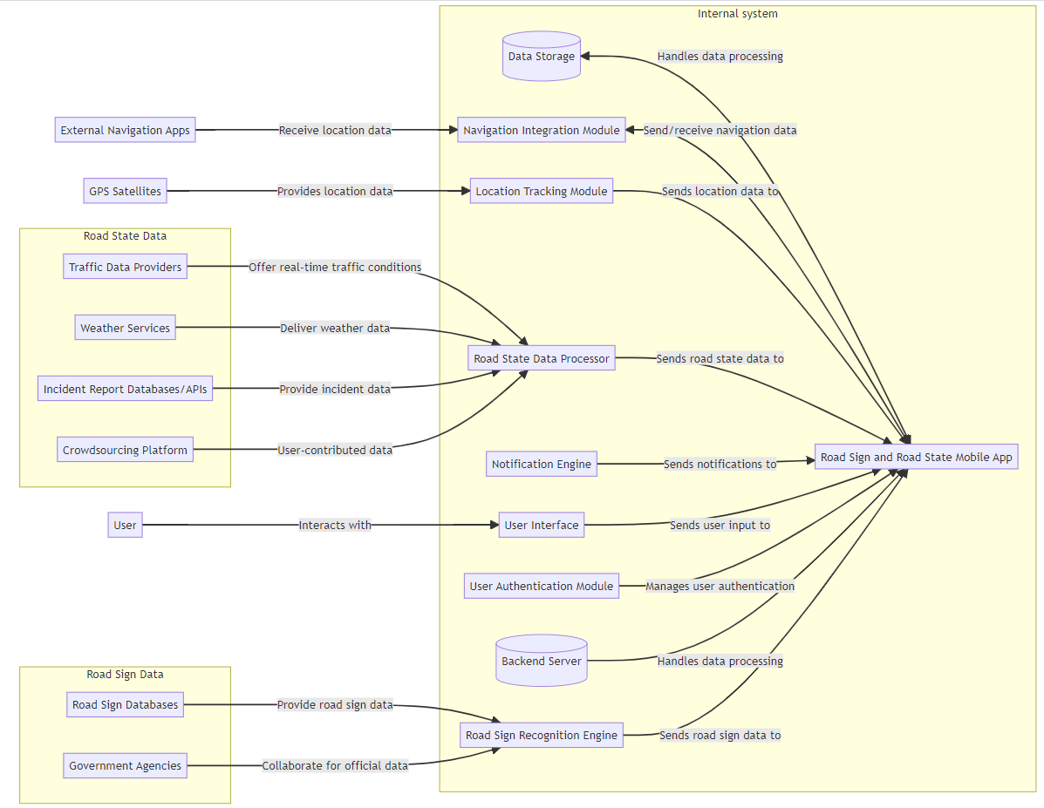

Figure 1: Context Diagram

|  |  |
| --- | --- |
| External Entity | Description |
| User | Users (drivers, cyclists, pedestrians) interact with the User Interface (UI) to access information about road signs and road conditions. They input preferences and receive notifications through the UI. |
| GPS satellites | GPS satellites provide location data to the Location Tracking Module (LT). This data is essential for determining the user's current location and providing relevant notifications and updates based on their geographical position. |
| External Navigation Apps | These apps receive location data from the Navigation Integration Module (NIM). This integration allows users to access road sign information and road state updates within their preferred navigation app. |
| Traffic Data Providers | Traffic data providers offer real-time traffic conditions to the Road State Data Processor (RSDP). This information includes details about traffic congestion, road closures, and other relevant traffic events. |
| Weather Services | Weather services deliver current and forecasted weather data to the Road State Data Processor (RSDP). This data helps in providing users with weather-related road condition updates. |
| Incident Report Databases/APIs | These databases provide incident data such as accidents, road closures, and other hazards to the Road State Data Processor (RSDP). This information is used to alert users about potential road safety issues. |
| Crowdsourcing Platform | Users contribute real-time road condition reports through the Crowdsourcing Platform, which provides this user-contributed data to the Road State Data Processor (RSDP). This enhances the accuracy and timeliness of road condition updates. |
| Government Agencies | Government agencies collaborate with the Road Sign Recognition Engine (RSRE) to ensure the app displays official road sign data and complies with legal requirements. |
| Road Sign Database | Road sign databases provide comprehensive road sign data to the Road Sign Recognition Engine (RSRE). This data is used to identify and interpret road signs captured by the app. |

This context diagram effectively shows how the Road Sign and Road State Mobile Application interacts with both its internal modules and various external entities. Each external entity provides essential data or services that the application processes and uses to deliver accurate and timely information to its users. The interaction between these entities ensures that users receive comprehensive, real-time updates on road signs and road conditions, enhancing their safety and driving experience.

* 1. **Use case Diagram**

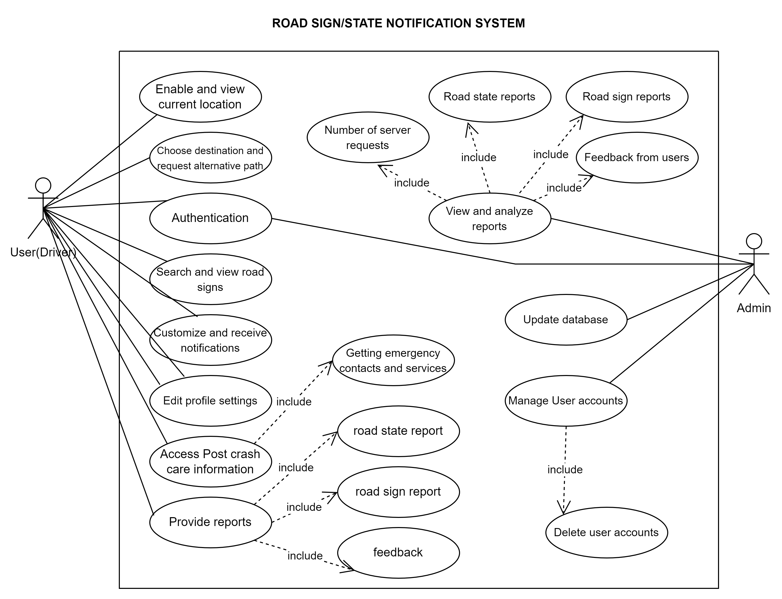

Figure 2: Use case Diagram

* + 1. **Use cases for Users (Drivers)**

|  |  |
| --- | --- |
| Use Case | Description |
| Authentication | The user enters their credentials (username/email and password) or uses third party login. The app verifies these credentials against its database. Upon successful authentication, the user gains access to personalized settings. |
| Enable and view current location | The app requests permission to use location services. Once granted, it continuously tracks and updates the user’s current location. The current location is then displayed on the app’s map interface, providing a real-time view of where the user is. |
| Choose Destination and Request Alternative Path | The app processes the input destination and generates the best possible route. If the user requests alternative paths, the app calculates and displays several route options, considering current road conditions, traffic, and road signs. The user can view different route options and choose the most suitable one based on real-time conditions. |
| Search and View Road Signs | The user enters keywords or uses voice search to find information on road signs. The user views detailed information about the road signs, including their meanings, locations, and any related warnings. |
| Customize and Receive Notifications | The user sets preferences for notifications. The user receives real-time notifications based on their preferences. |
| Edit Profile Settings | Users can customize their account (the section of the app in which users can control their profile and other settings in relation to their account on the app) |
| Access Post Crash Care Information | The user selects the post-crash care option from the main menu or a dedicated button. The app then provides a list of steps to take, emergency contact numbers, and nearby hospitals or services. |
| Provide Reports | The user fills out a report from within the app, detailing the issue or incident, and may attach photos or videos as evidence. The submitted report is reviewed and the users may receive updates. |

* + 1. **Use cases for Admins**

|  |  |
| --- | --- |
| Use Case | Description |
| **Manage User Accounts** | * The admin monitors user activity to ensure compliance with usage policies and to detect any unusual behaviour that might indicate a security issue. * The admin can send notifications to users about system updates, policy changes, or other important information. |
| **Update Database** | * When new road signs or conditions are reported, the admin adds these entries to the database, including details like location, type, and any relevant notes. * If there are changes to existing road signs or conditions (e.g., a road construction project is completed), the admin updates the relevant database entries. * The admin may perform regular backups of the database to prevent data loss. |
| **View and Analyse Reports** | Based on the analysis, the admin can make informed decisions on necessary updates or improvements to the system. |

* 1. **Class Diagram**

Below is the detailed class diagram that captures the internal structure and relationships of the road sign and state notification system, integrating the **admin** entity and reflecting the system's comprehensive functionality.

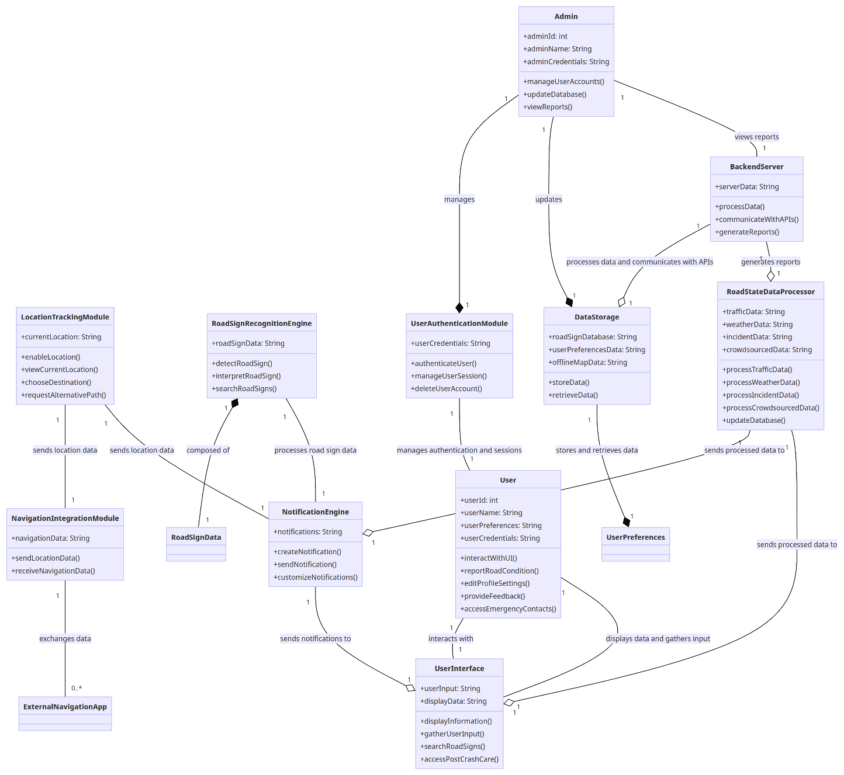

Figure 3:Class diagram

* + 1. **Explanation of Class Diagram**

**User to UserInterface:**

* **Association**: A *User* interacts with the *UserInterface* to perform various operations.

**Admin to UserAuthenticationModule and DataStorage:**

* **Aggregation**: An *Admin* manages *UserAuthenticationModule* and *DataStorage*. The *Admin* can manage these independently.

**Admin to BackendServer:**

* **Association**: An *Admin* views reports generated by the *BackendServer*.

**LocationTrackingModule to NavigationIntegrationModule and NotificationEngine:**

* **Association**: *LocationTrackingModule* sends location data to both *NavigationIntegrationModule* and *NotificationEngine*.

**NavigationIntegrationModule to ExternalNavigationApp:**

* **Association**: *NavigationIntegrationModule* exchanges data with external navigation applications.

**NotificationEngine to UserInterface:**

* **Aggregation:** *NotificationEngine* sends notifications to the *UserInterface*, but the *UserInterface* can exist independently.

**RoadSignRecognitionEngine to RoadSignData:**

* **Composition:** *RoadSignRecognitionEngine* is composed of *RoadSignData*. Without *RoadSignRecognitionEngine*, *RoadSignData* does not exist.

**RoadSignRecognitionEngine to NotificationEngine:**

* **Association:** *RoadSignRecognitionEngine* processes road sign data and communicates this to *NotificationEngine*.

**RoadStateDataProcessor to NotificationEngine and UserInterface:**

* **Aggregation:** *RoadStateDataProcessor* sends processed data to both *NotificationEngine* and *UserInterface*.

**UserInterface to User:**

* **Association:** *UserInterface* displays data to and gathers input from the *User*.

**DataStorage to UserPreferences:**

* **Composition:** *DataStorage* is composed of *UserPreferences*. Without *DataStorage*, *UserPreferences* does not exist.

**UserAuthenticationModule to User:**

* **Association**: *UserAuthenticationModule* manages user authentication and sessions.

**BackendServer to DataStorage and RoadStateDataProcessor:**

* **Aggregation:** *BackendServer* processes data stored in *DataStorage* and communicates with *RoadStateDataProcessor* to generate reports.
  1. **Sequence Diagram**

The sequence diagram outlines the interaction between the user (driver), admin, mobile application, and various external systems to accomplish different use cases in the Road Sign/State Notification System.

* + 1. **Explanation of Sequence Diagram**

**User Authentication:**

* The user opens the application, which prompts them to sign up or log in.
* If signing up, the mobile app verifies credentials with the database and confirms registration.
* If logging in, the mobile app verifies credentials and confirms access.
* If there's an error, the user is prompted to re-enter credentials.

**Notification Preferences:**

* The user sets their notification preferences, which the mobile app updates in the database.

**Location Services:**

* The user enables location services to view their current location.
* The mobile app retrieves the current location from the GPS.

**Navigation:**

* The user chooses a destination and requests an alternative path.
* The mobile app integrates with an external navigation system (e.g., Google Maps) to provide alternative path data.

**Road Sign Information:**

* The user searches for and views road signs.
* The mobile app fetches road sign information from crowdsourced data and displays it.

**Customize Notifications:**

* The user customizes notifications to receive updates on road conditions, traffic reports, and weather data.
* The mobile app requests data from crowdsourced sources, traffic cameras, and weather APIs and sends notifications based on user preferences.

**Profile Management:**

* The user edits their profile settings, which the mobile app updates in the database.

**Post Crash Care:**

* The user accesses post-crash care information to get emergency contacts and services.
* The mobile app fetches this data from the database.

**Reporting:**

* The user provides reports on road conditions and signs, and feedback.
* The mobile app updates the database with these reports.

**Admin Functions:**

* The admin views and analyzes reports, fetching various data from the database (road state reports, road sign reports, server request counts).
* The admin updates the database and manages user accounts, including deleting user accounts.

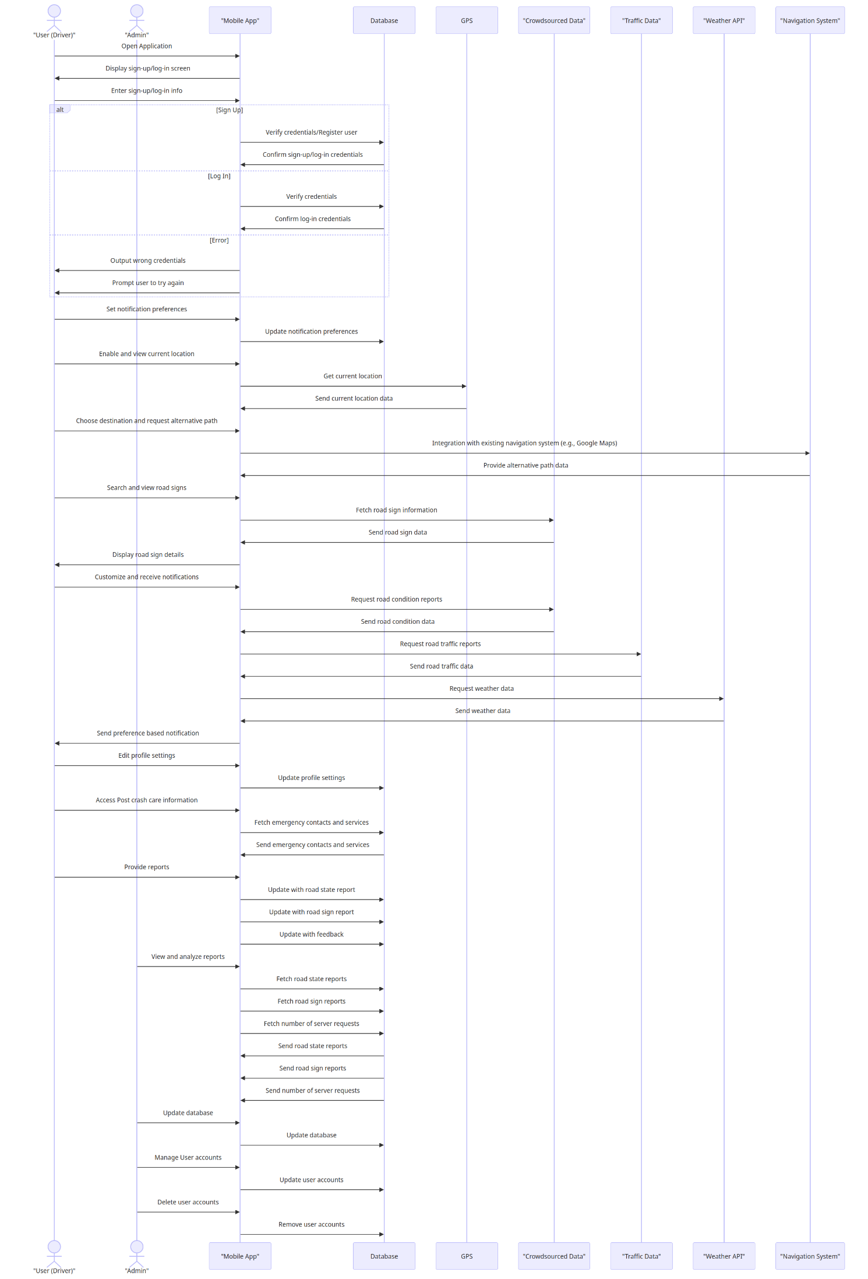

Figure 4:Sequence Diagram

* 1. **Deployment Diagram**

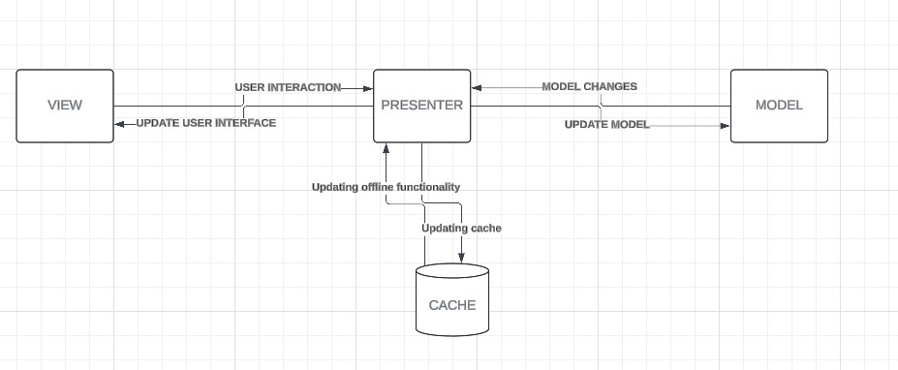

Figure 5:MVP deployment abstraction diagram

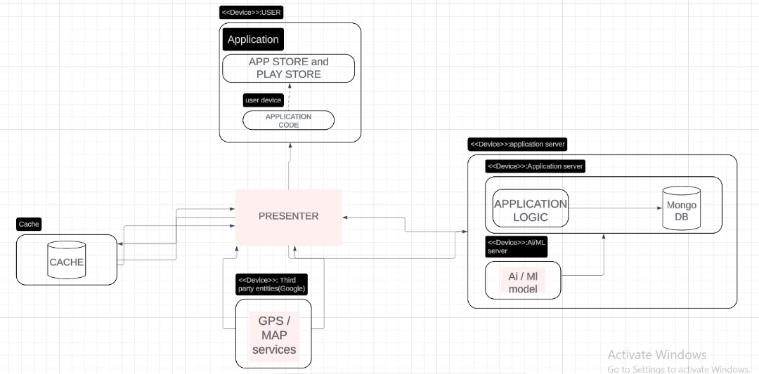

Figure 6:Detailed Deployment Diagram

* + 1. **Explanation of Deployment Diagram**

**Model View Presenter**

1. **Model:**

It represents the data and business logic of the application that is, it handles data, access to that data (from the databases and other sources) as well as it defines the core logic and rules which are used to govern the application’s behavior or decision making. And it doesn’t interact with the user interface except with the use of the presenter.

* **Nodes in the model**
* **Application/Backend server**

This represents the server that stores the core application data and handles server-side logic.

* **Database**

Within the backend server, depict a database symbol representing where user information, road signs, and state reports and real-time traffic data reside.

Mongo DB is used because data about the mobile road sign and road state are not structured and due to its ever-changing nature, data generated might not fit neatly in relational tables. Also, NoSQL databases can efficiently handle a high volume of frequently updated data.

* **Other reasons for choosing NoSQL over SQL are**
  + Performance
  + Scalability
* **The Ai and ML model:**

This represents the machine learning model that feeds the logical layer (application server) and attempts to give the user a solution the signs on the road.

1. **View**

This represents the visual elements of the application that the user interacts with. It's responsible for displaying information retrieved from the model in a user-friendly format. The view doesn't perform any calculations or data manipulation, it just presents the data as instructed by the presenter.

* **Nodes in the view**
* The user device:

Represent the user's smartphone or tablet where the mobile application runs. This node hosts the app store and play store where the application can be downloaded and installed.

* The application code:

This is referring to the logic code that resides on the client-side to understand the inputs from presenter originating from the cache memory.

1. **Presenter**

This acts as an intermediary between the View and the Model. It receives user input (such as clicks, form submissions, etc.) and processes it. The Presenter then fetches data from the Model as needed and formats it for presentation by the View. It essentially controls the flow of information between the View and the Model, acting as the "brains" behind the user interface.

* **Cache**

The cache is responsible for storing data locally in case the users encounter poor network connectivity thus enhancing user experience

* **Third party Entities**

Third party services in charge of maps, Traffic Data Providers, Weather Services and External Navigation Apps provide information to the presenter by making use of APIs.

* **Benefits of MVP Architecture**

• **Improved Separation of Concerns:** MVP promotes modularity by separating the data (Model), presentation (View), and application logic (Presenter) thus improving code maintainability, reusability, and testability. Developers can focus on specific parts without worrying about the intricate workings of other components.

• **Enhanced Testability and maintainability:** Due to its modular nature each component (Model, View, Presenter) can be tested independently, simplifying the testing process and ensuring the overall application functions as intended.

# **CHAPTER FIVE: UI DESIGN AND IMPLEMENTATION**

1. **Low fidelity**
   1. **Sitemap:**

A sitemap in UI/UX design is a visual or text-based representation of a website's structure, illustrating the relationships between different pages and content sections. It serves as a blueprint for the site, helping designers, developers, and stakeholders understand the site's hierarchy and navigation flow.

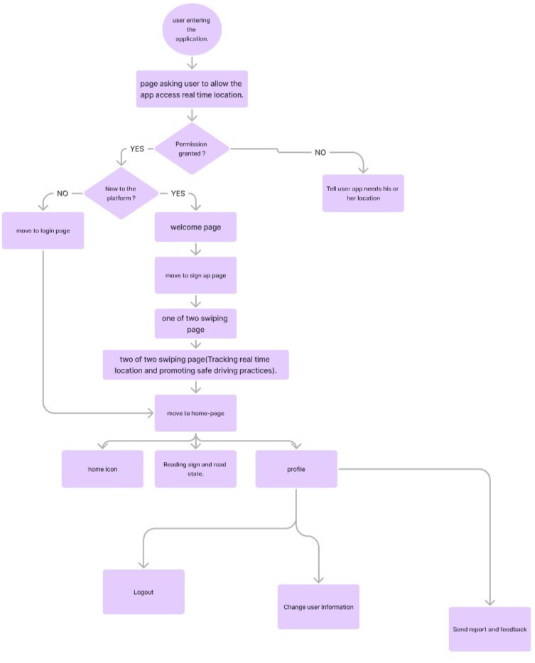

Figure 7: Site map

* 1. **Explanation of the above sitemap:**

When a user gets in the system it requests for the user to grant it location permission.

If the user is a new user he is taken to a welcome page, then proceeds to a sign-up page otherwise if the user is an old user, he is asked to either sign-in (if accessing the app from a new device).

He then proceeds to the home page where he gets a navigation bar (home, documentation, profile).

In the home he gets the possibility to search for a location where he intends to go to or see his real-time location.

From the documentation menu he can search and view road signs.

**Profile:**

In the profile section the user can set a profile picture, change or update his username, email or desired notifications.

1. **Introduction to design systems:**

In UI/UX design, a design system is a comprehensive set of standards, guidelines, components, and practices that work together to create a consistent and cohesive user experience across digital products.

The set of design systems that were built and used through this project are:

* Button state and types.
* Font type and Face.
* A set of Icons.
* A navigation bar

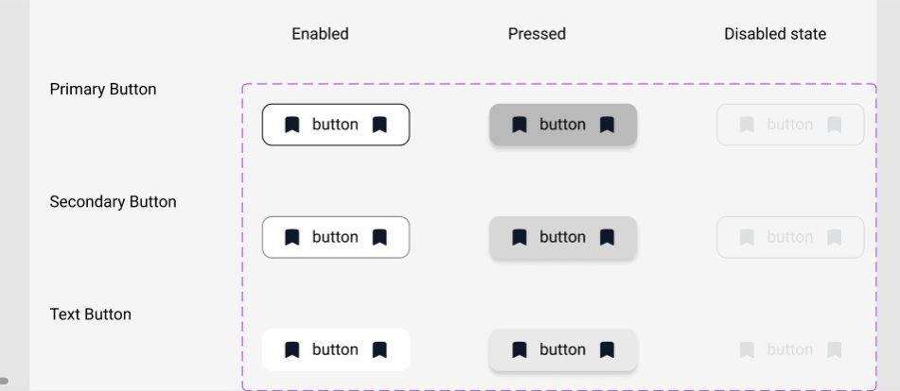

First is a set of button types and button state that exist in the app. The button states and types are primarily implemented in black and white (low fidelity) this is to ensure that visually impaired user navigating this application should have the same user experience as every other user.

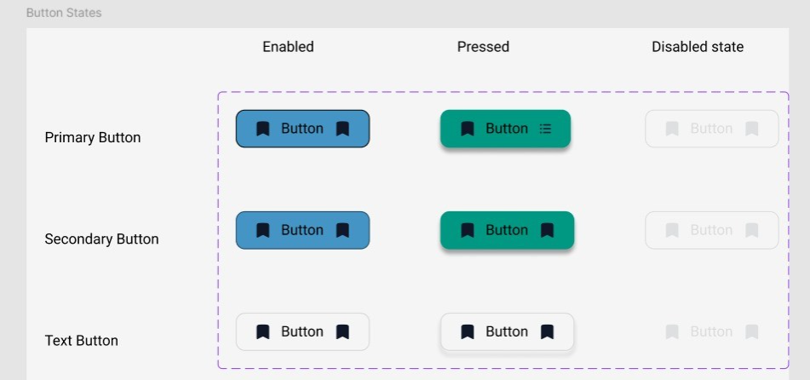

A button can have three states:

* enabled
* pressed
* disabled

The text denotes an input field that has or doesn’t have an icon.

Here a button is of a Boolean value denoting whether the button should contain a left or right icon.

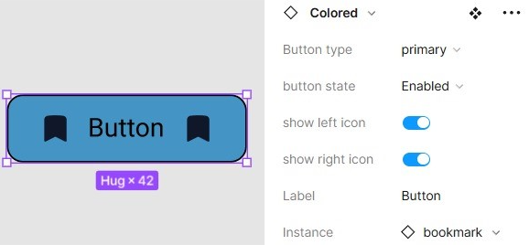

Below are more types of buttons that can exist in this app.

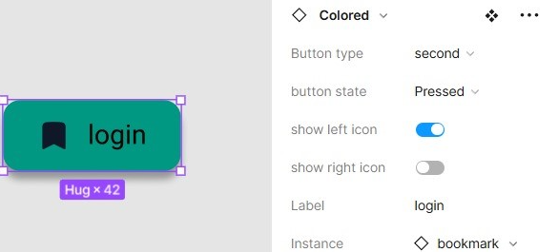

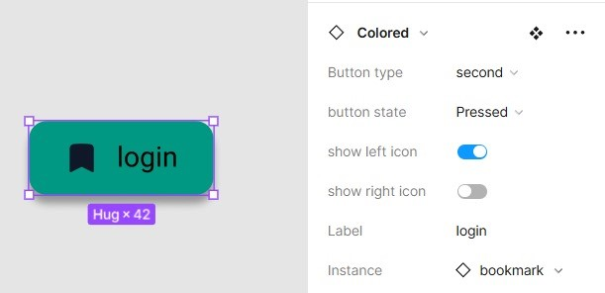

* 1. **Color palette:**

The color palettes used consist of

* Green
* Blue
* Black



Figure 8: color palette

Here the 60-30-10 rule was used with green being the domain black indicating the call-to-action button(text) and blue indicating state button in case a button is pressed.

* 1. **The fonts type, style and face:**

Here a sans serif ***Roboto*** font was used.

Different type faces were used of font weight 8,14, 18 namely:

* Small
* Regular
* Bold
* Extra bold

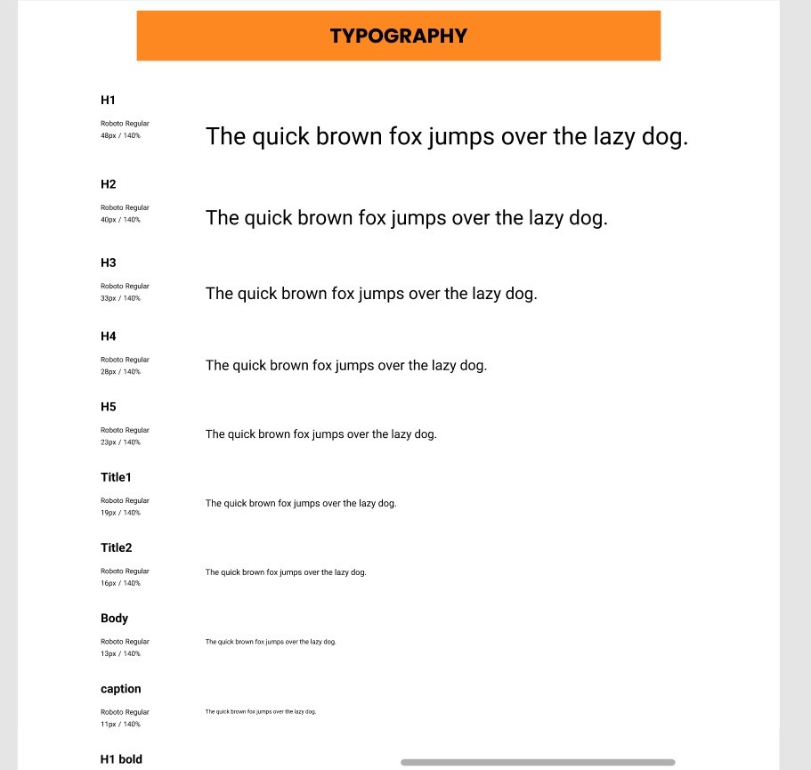

Figure 9: Typography 1



Figure 10: Typography 2

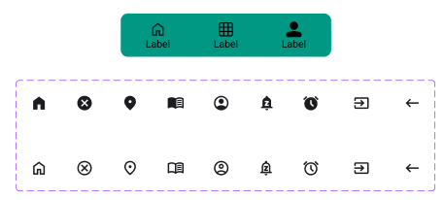

Figure 11: Icons

Above is a set of icons used throughout the app. These icons consist of filled and unfilled.

* Filled icons show active state
* No-fill icons show non active state.
  1. **Benefits of a Design System:**

1. **Consistency:** Ensures a unified look and feel across all digital products, enhancing brand recognition and user trust.
2. **Efficiency:** Speeds up the design and development process by providing reusable components, reducing the need to create elements from scratch.
3. **Scalability:** Facilitates the maintenance and updating of large-scale applications by providing a centralized repository of design assets.
4. **Collaboration:** Enhances collaboration between designers, developers, and other stakeholders through shared language and resources.
   1. **Quality:** Improves the overall quality and usability of products by adhering to established best practices and guidelines.
5. **High fidelity design.**

8. 1. **User Interface**

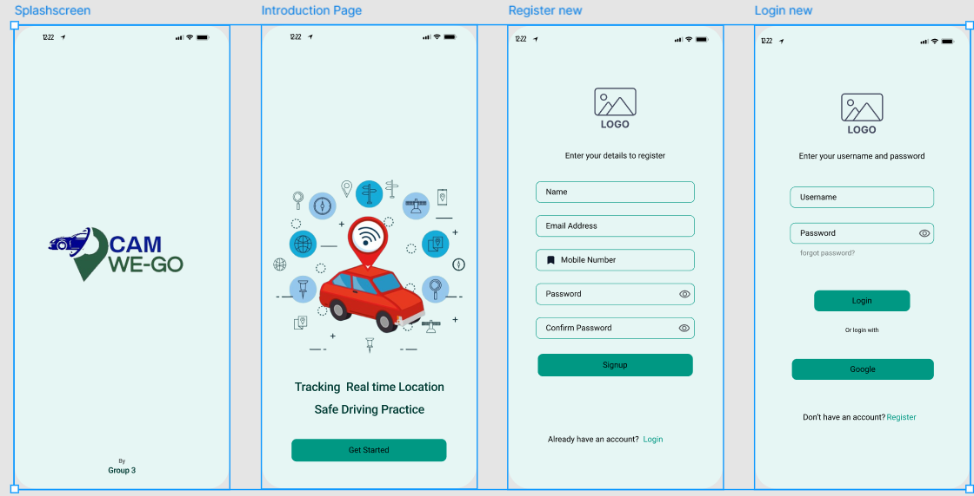

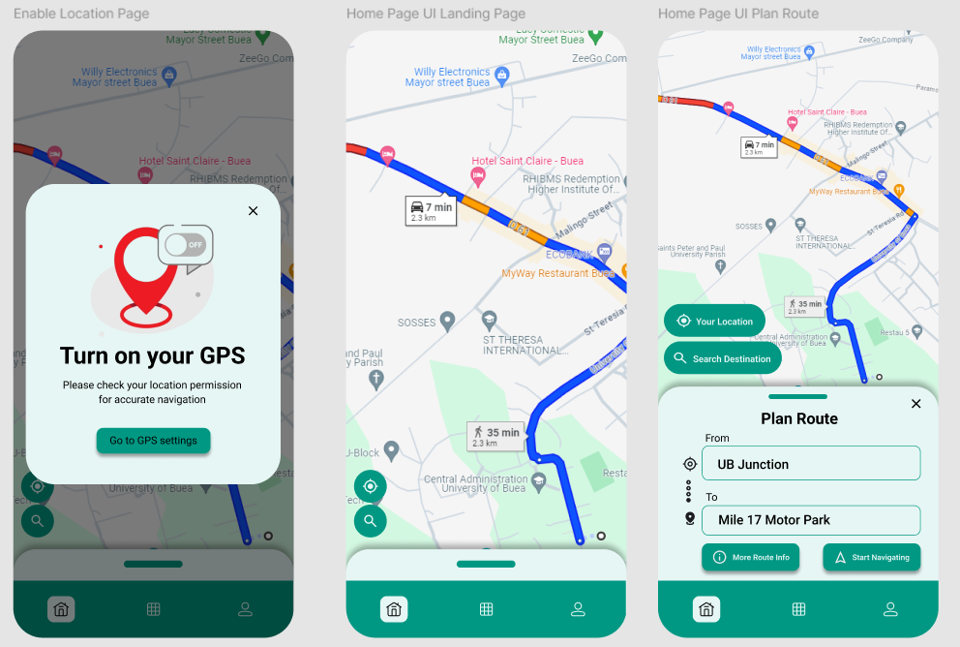

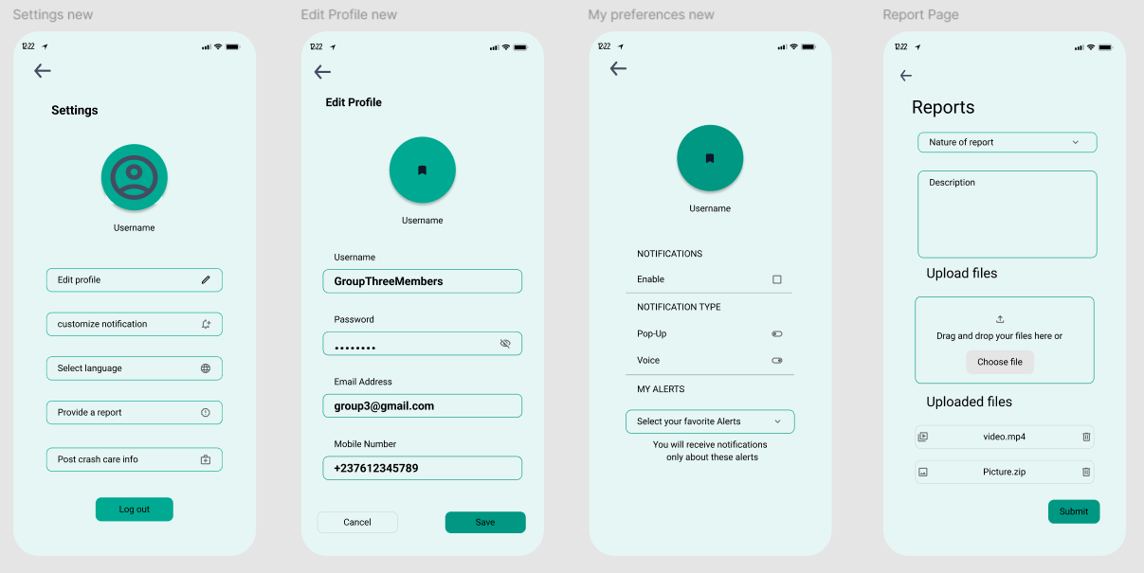

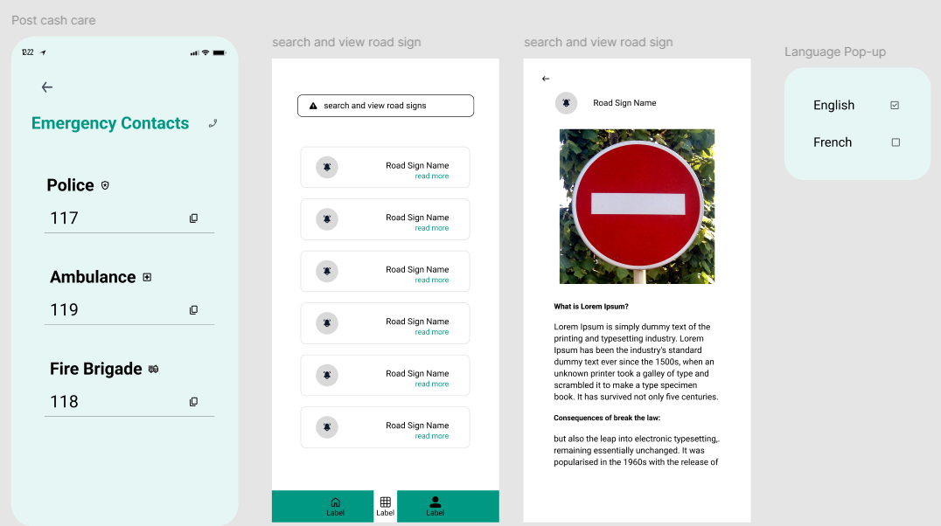

* 1. **Administrator’s Dashboard**

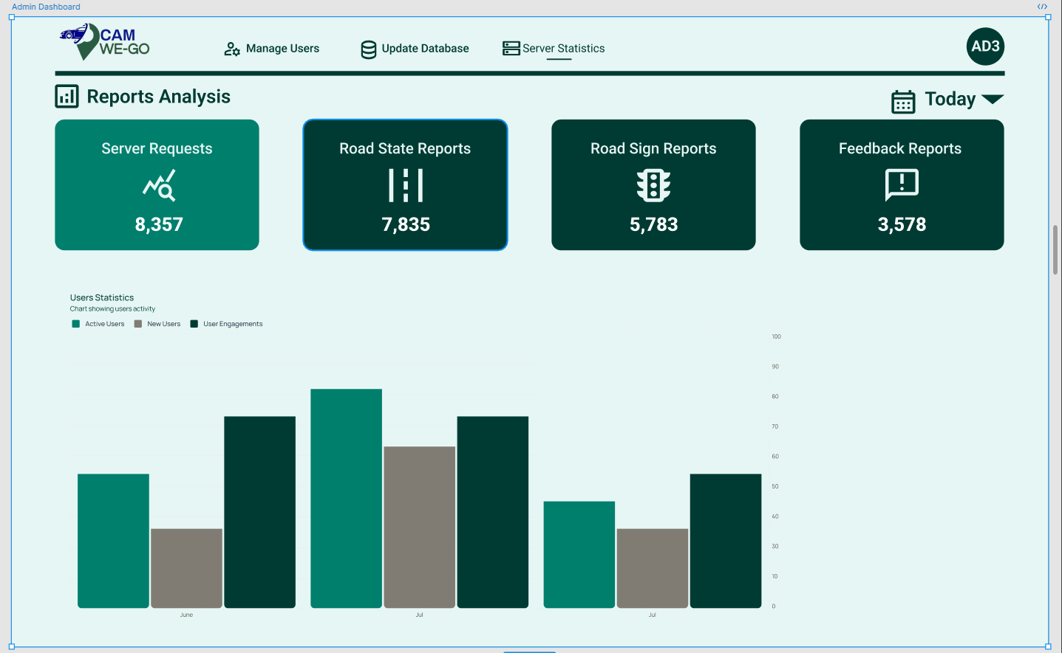

Figure 12: Dashboard

# **CHAPTER SIX: DATABASE DESIGN AND IMPLEMENTATION**

1. **Identification of Data Sources**

The various entities of our system originate from various sources that can be from APIs as well as User interaction.

The different data sources are:

* Google maps Api
* Weather Api
* Road sign database
* User interface

1. **Extraction of Constituent Entities of the System**

The following are the entities of our system and their respective attributes:

1. **User entity**

This represents each user of our system, and it is a strong entity. The constituent attributes are:

• username

• user Email

• user number

• user password

• user identity

• road state preferences

• road sign preferences.

1. **Road Sign entity**

This entity represents each road sign that exist in our system and with attributes:

• Name

• Image-link

• Usage

• purpose

• about

• penalty id

• Category id

• priority.

This is a strong entity but because each sign post has a unique geographical location this gives rise to a weak entity, Road sign Location entity with attributes (Name, longitude, latitude)

1. **Report table:**

User of our road sign and road state notification system can publish reports. Which is a weak entity because it is dependent of the user’s existence. It has the following attribute:

• Nature

• Description

• File-link

• Timestamp

• User id

1. **Road state entity:**

Each road has a state, hence the attributes:

• Road id

• Location

• Status

• TTL

• Name of incident

1. **Entity relation diagram**

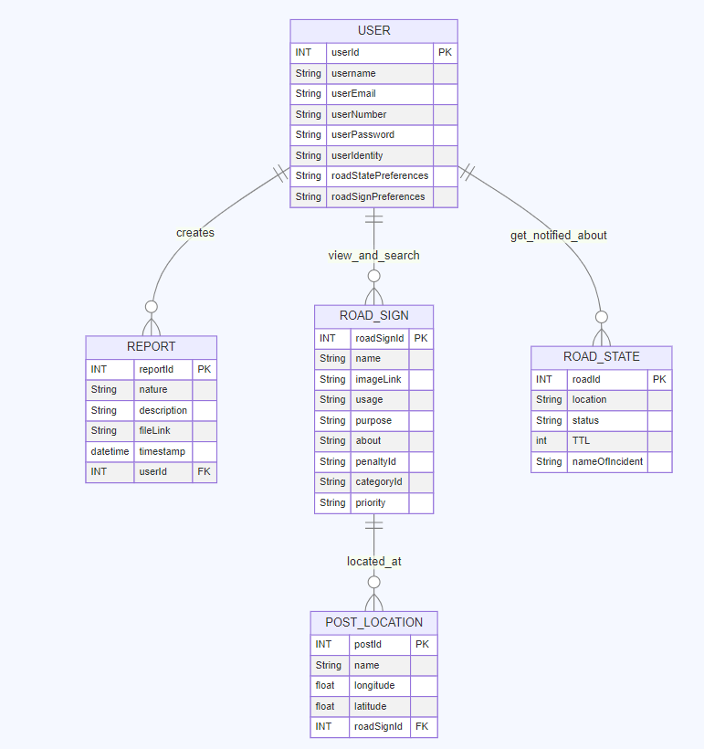

Figure 13:ER Diagram

1. **Implementation**

**Detailed Explanation of the ER Diagram**

The ER diagram outlines the structure and relationships of a system involving users, reports, road signs, post locations, and road states. Below is a detailed description of each entity, their attributes, and the relationships between them.

**Entities and Attributes**

1. **USER**

userId (PK): A unique identifier for each user.

username: The name of the user.

userEmail: The email address of the user.

userNumber: The contact number of the user.

userPassword: The password for the user's account.

userIdentity: A unique identity marker for the user.

roadStatePreferences: Preferences regarding road states.

roadSignPreferences: Preferences regarding road signs.

1. **REPORT:**

reportId (PK): A unique identifier for each report.

nature: The nature or type of the report.

description: A detailed description of the report.

fileLink: A link to a file associated with the report.

timestamp: The time when the report was created.

userId (FK): A foreign key linking to the USER entity, indicating which user created the report.

1. **ROAD_SIGN:**

roadSignId (PK): A unique identifier for each road sign.

name: The name of the road sign.

imageLink: A link to an image of the road sign.

usage: How the road sign is used.

purpose: The purpose of the road sign.

about: Additional information about the road sign.

penaltyId: An identifier for penalties associated with the road sign.

categoryId: An identifier for the category of the road sign.

priority: The priority level of the road sign.

1. **POST_LOCATION**

postId (PK): A unique identifier for each post location.

name: The name of the location.

longitude: The longitude coordinate of the location.

latitude: The latitude coordinate of the location.

roadSignId (FK): A foreign key linking to the ROAD_SIGN entity, indicating which road sign is located at this post.

1. **ROAD_STATE**

roadId (PK): A unique identifier for each road state.

location: The location of the road state.

status: The current status of the road.

TTL: Time to Live or the duration for which the road state is valid.

nameOfIncident: The name or description of the incident affecting the road state.

**Relationships**

1. **USER and REPORT**

A user can create multiple reports. This is a one-to-many relationship where a user (parent) can have multiple reports (children).

1. **USER and ROAD_STATE**

Users get notified about various road states. This is a one-to-many relationship where a user can receive notifications about multiple road states.

1. **USER and ROAD_SIGN**

Users can view and search for various road signs. This is a many-to-many relationship indicating that users can interact with multiple road signs, and each road sign can be viewed by multiple users.

1. **ROAD_SIGN and POST_LOCATION**

Each road sign can be located at multiple post locations. This is a one-to-many relationship where a road sign (parent) can be associated with multiple post locations (children).

This ER diagram provides a clear and organized representation of the system's entities and their interrelationships. The primary keys ensure that each record is uniquely identifiable, while the foreign keys maintain the integrity and linkage between related entities. This structure facilitates efficient data management and retrieval, ensuring that users can create reports, get notified about road states, and interact with road signs effectively.

1. **Other Factors considered**

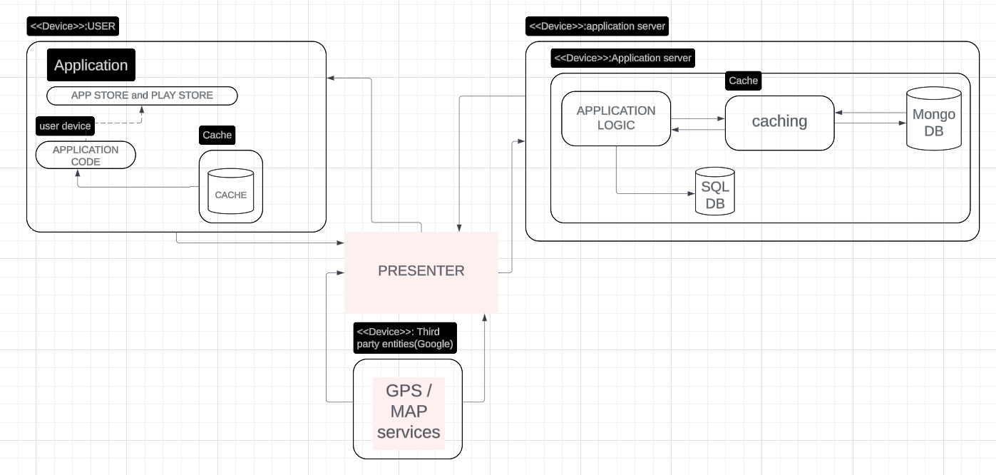

Figure 14:Updated Deployment Diagram

Here is an updated deployment diagram.

**1) Speed:**

Since this system deals with real-time data, there is need for a fast response to changes in the environment. To attend to this, need the following were used:

**A NoSQL database:**

Mongo DB which is a NoSQL database is used because of its simple queries speed and ability to effectively handle larger datasets.

**Caching:**

Caching is implemented between the NoSQL database and the server to reduce write and read time hence decreasing the load time.

**2) Security:**

Real-time location of our users is the main data our system deals with, this calls for the need of keeping the user's location private and accessible only by the system. These are the following solutions proposed

**Tokenization:**

This is implemented on both the server-side and client-side to prevent unauthorized access.

**Data encryption:**

This is done by encrypting the data resulting from the different nodes before storing in the database.

**3) Documentation purposes:**

In accordance to the context diagram, where it was stated that external entities such as the government can interact with our platform, a relational database has been added for archiving purposes. Hence external bodies such as the government can use this data to visualize or extract insights on the road experience.

**References**

[1] Mobility, S. A. (2023, December 13). Global status report on road safety 2023. <https://www.who.int/publications/i/item/9789240086517>

[2] Cameroon. (n.d.). <https://www.roadsafetyfacility.org/country/cameroon>

[3] Kwalar, G. I., Siysi, V. V., Asangbeng, T. E., Jules-Clement, A. N., & Shey, N. D. (2021). Trends and Contributing Factors to Road Traffic Accidents in Douala. Trends and Contributing Factors to Road Traffic Accidents in Douala, 9(1), 24–31. <https://doi.org/10.12691/ajeid-9-1-5>

[4] Wikipedia contributors. (2024, April 10). Here WeGo. Wikipedia. <https://en.wikipedia.org/wiki/Here_WeGo>

[5] Masatu, E. M., Sinde, R., & Sam, A. (2022). Development and testing of Road Signs alert system using a smart mobile phone. Journal of Advanced Transportation, 2022, 1–14. https://doi.org/10.1155/2022/5829607 (1)

[6] Babalola, O. (2023). Data Protection Legal Regime and Data Governance in Africa: An Overview. In Springer eBooks (pp. 71–96). https://doi.org/10.1007/978-3-031-24498-8_4